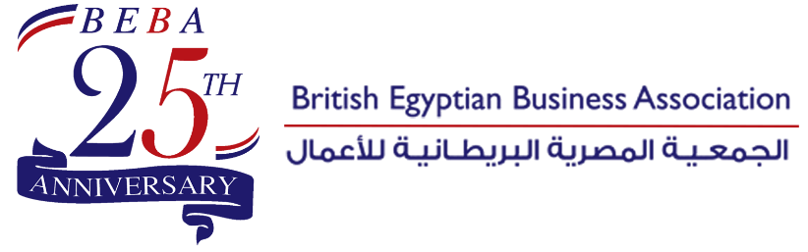

Sponsorship Packages

Categories | Benefits
Platinum Sponsor  80,000 EGP | - One table accommodating 6 persons  - Chairman of the company to be seated AT THE HEAD TABLE  - Company’s logo to be placed on BEBA’s event banner  - Company’s logo to be placed on the name tag cards  - Company’s brochures/ flyers to be displayed in a booth or at a literature table  - Company’s logo to be placed on a centre piece stand on the table  - Four company’s roll ups to be displayed in ballroom & at foyer
Gold Sponsor  40,000 EGP | - One table accommodating 6 persons  - Chairman of the company to be seated AT ONE OF THE HEAD TABLES  - Company’s logo to be placed on BEBA’s event banner  - Company’s logo to be placed on the name tag cards  - Company’s brochures/ flyers to be displayed in a booth or at a literature table  - Company’s logo to be placed on a centre piece stand on the table  - Two company’s roll ups to be displayed in ballroom & at foyer
BEBA Members  Table of 6 persons  17,000 EGP | - One table accommodating 6 persons  - Company’s name on BEBA’s event banner  - Company’s logo to be placed on a centre piece stand on the table
BEBA Non-Members  Table of 6 persons  20,000 EGP | - One table accommodating 6 persons  - Company’s name on BEBA’s event banner  - Company’s logo to be placed on a centre piece stand on the table

