Elections of the BEBA Board of Directors (2022-2026)
List of Nominees (sorted alphabetically by last name)

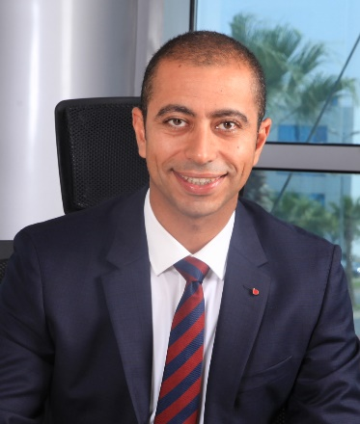

Mohamed Abdallah
Chief Executive Officer
Vodafone Egypt

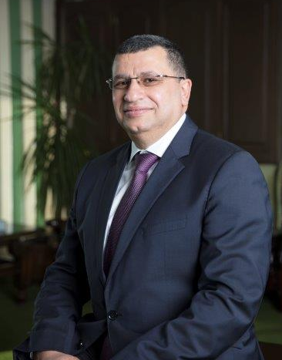

Dr. Ahmed Ezzeldin Abdelaal
Group CEO
Cleopatra Hospitals Group

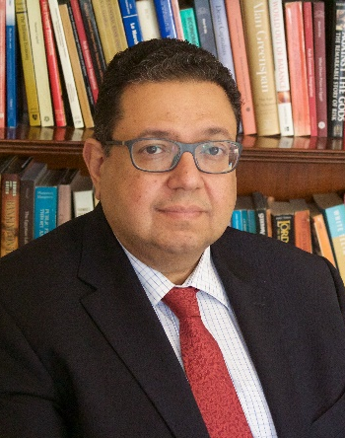

Dr. Ziad Bahaa El Din
Managing Partner
Thebes Consultancy

Ghada Darwish
Country Manager
Globeleq

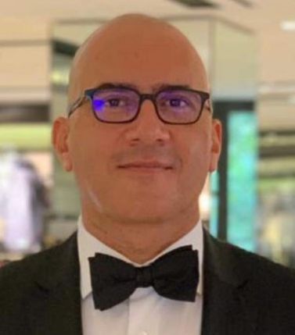
Mohamed El Dababy
General Manager Egypt
GlaxoSmithKline

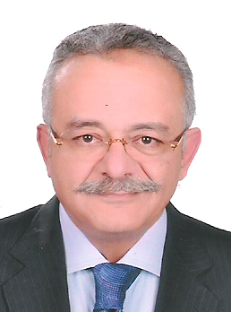
Maged El Menshawy
Chairman
Manapharma

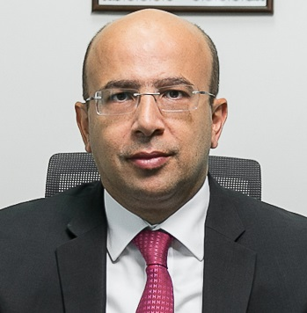

Maged Ezzeldeen
Egypt Senior Partner & Deals Leader
Pricewaterhousecoopers LLC (PwC)

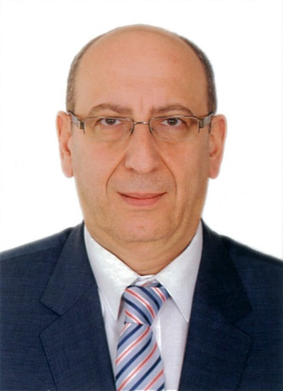

Hazem Gohar
Director of Water & Environment Department – Managing Director - Cairo
Dar Al-Handasah Consultants (Egypt) Ltd.

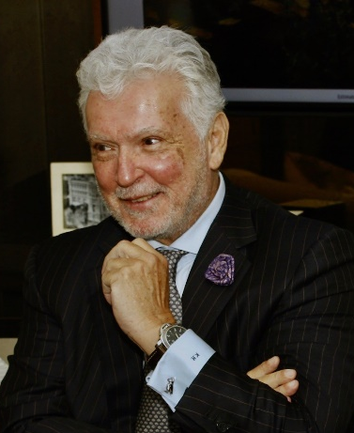

Karim Helal
Director Egypt
Colliers International

Sara Hinton
Senior Partner I&P
Ibrachy Legal Consultancy

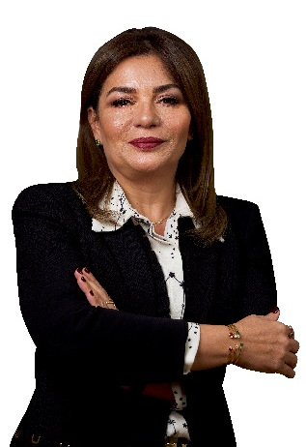

Pakinam Kafafi
Chief Executive Officer
TAQA Arabia

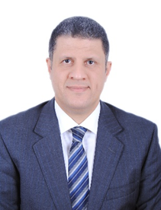

Mohanad T. Khaled
Managing Partner
BDO Khaled & Co.

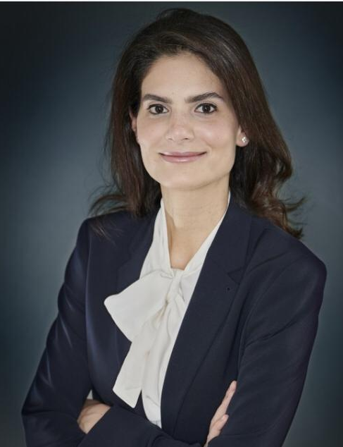

Malak Khalil
Counsel and Head of Energy, Environmental and Natural Resources practice group
ADSERO – Ragy Soliman & Partners

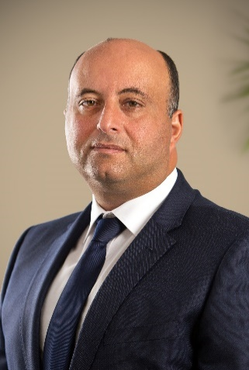

Ihab Mehawed
Managing Director
Orascom Construction

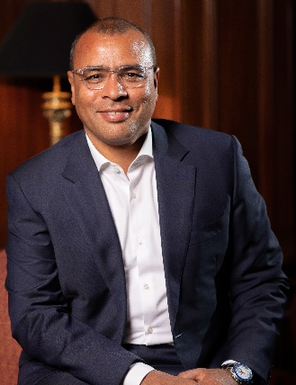

Ahmed Mekky
Chairman & CEO
FiberMisr (Benya Capital)

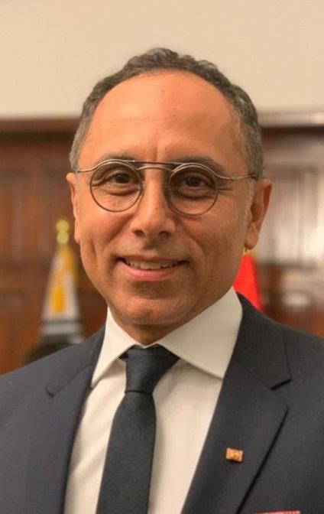

Khaled M. Nosseir
Chairman
Alkan Holding

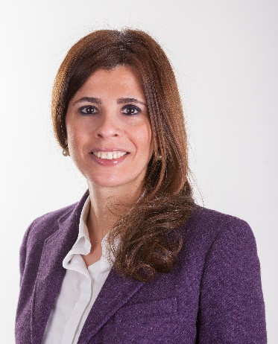

Dr. Ingy Rasekh
Managing Partner
Mena Associates/Amereller Legal Consultants

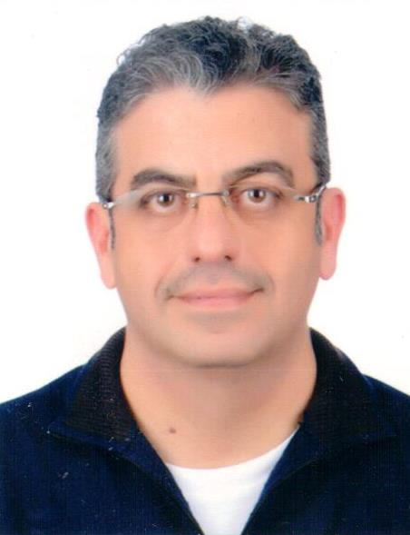

Sherif Rashad
Managing Partner - CEO
Magicpharma

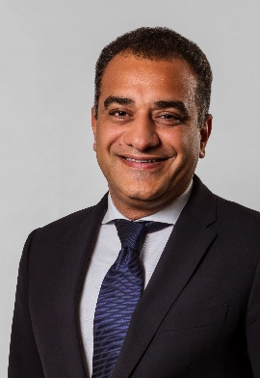

Karim Refaat
Chairman & Chief Executive Officer
N Gage Group

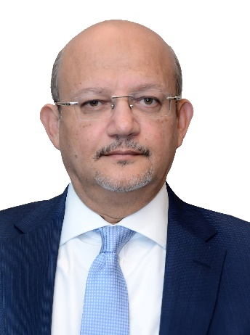

Hussein Refaie
Chairman & Managing Director
Suez Canal Bank

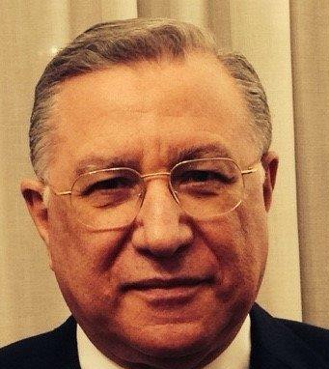

Dr. Negad Shaarawy
Chairman of the Healthcare & Pharmaceutical Sub Fund
Sovereign Fund of Egypt
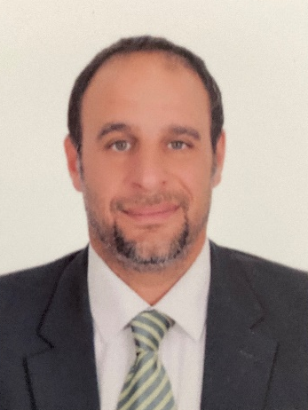

Khaled Zaki
Chief Operating Officer, COO
Dar El-Mimar Construction-DMC

